**ARYAMAN MISHRA**

**19BCE1027**

Write an 8086 ASM code to perform the following operations

1. Display a given string

ASSUME CS:CODE,DS:DATA

DATA SEGMENT

STRG DB "ARYAMAN$"

DATA ENDS

CODE SEGMENT

START:

MOV AX,DATA

MOV DS,AX

MOV AH,09H

MOV DX,OFFSET STRG

INT 21H

INT 3

CODE ENDS

END START

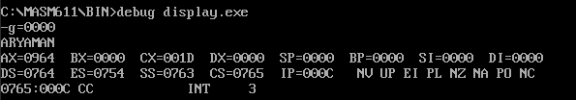

1. calculate the length of the string

assume cs:code,ds:data

data segment

strg db "sakthivel$"

msg db "the lenght of the string is:$ "

data ends

code segment

start:

mov ax,data

mov ds,ax

mov ax,0000h

mov cx,0000h

mov al,"$"

lea si,strg

loop1:

mov ah,[si]

cmp al,ah

je ter

inc cx

inc si

jmp loop1

ter:

mov dx,offset msg

mov ah,09h

int 21h

mov dx,0000h

mov dl,cl

add dl,30h

mov ah,02h

int 21h

mov ax,4c00h

int 21h

hlt

code ends

end start

